**Assignment-25:**

**Use the Store_Data data and do the following**

**- Create a Pie Chart Drill Down in terms of Sales and Product category & Product Sub- Category**

**- Need to use the concept of Dual Axis**

**- Your Chart should show the layers for each Sales Categories like 1st Layer for Product Category , 2nd Layer for Product Sub Category**

Under Connect section, click on "Microsoft Excel" and browse through the location where "Store_Data" excel file exists to connect.

After connecting to "Store_Data" excel data,

Drag and drop "Orders" , "Returns" and "Users" tables to Data Model section to make connections between the tables.

Go to sheet 1 and rename it of your choice.

step 1) Change the Mark type from "Automatic" to "Pie".

step 2) Drag and drop "Product Category" dimension on to Color under Marks card.

step 3) Drag and drop "Sales" measure on to Angle under Marks card.

step 4) Right click on "Product Category" color pill under Marks card and click on "Sort" option.

A window "Sort [Product Category]" pop ups.

step 5) Change "Sort By" to "Field" option and keep the remaining fields as it is as shown below:

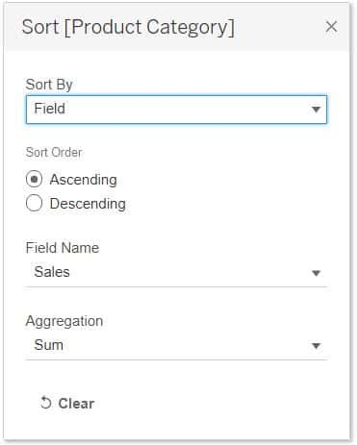

step 6) Change the view type to "Entire View".

step 7) Click on Size under Marks card and drag the slider to increase the size of pie chart a little bit for a better visual appeal.

step 8) Right click on "Product Category" dimension and click on "Create" then click on "Set".

Give the name as "Category Set".

For now, lets just tick mark "Furniture" checkbox and click on OK.

We can see "Category Set" gets created under Tables section.

Now, lets create a calculated field and make use of this "Category Set":

step 9) Click on "Analysis" and click on "Create Calculated Field".

A Calculated Field window pop ups.

Give the name as "Cat to SubCat" and give the formula as shown below:

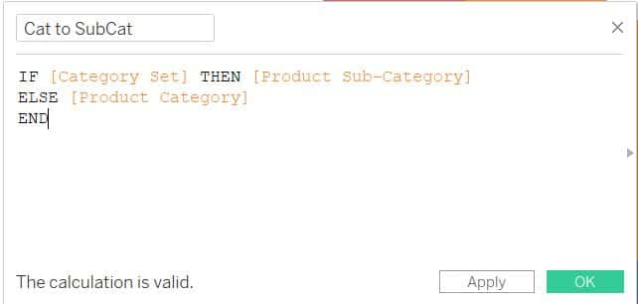

It means if the user choose category set then it returns product sub category else returns product category. That means our target is when a user hovers their mouse on a category type, then it should display sub categories within that set automatically.

Now,  basically we need a pie chart inside another pie chart. for this, we need to create an axis and use dual axis technique.

lets create a dummy axis with avg(0) in columns shelf twice.

step 10) Type avg(0) in Columns shelf and press enter. Do it again to create another one within this Columns shelf.

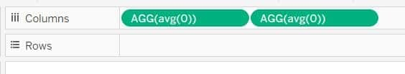

step 11) Right click on these two pills and uncheck "Include in tooltip" option for both pills.

Now, we can see two pie charts get created side by side.

step 12) Click on the Size under Marks card and drag the slider to increase both the charts.

step 13) Drag and drop "Cat to SubCat" dimension on to Detail under second "AGG(avg(0))" Marks card.

step 14) Now, change the "Cat to SubCat" from detail type to Color type by clicking on ... dots beside "Cat to SubCat" pill as shown below:

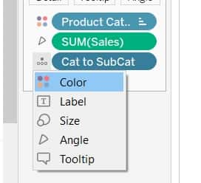

lets sort the sort the second pie chart:

step 15) Right click on "Cat to SubCat" color pill under second "AGG(avg(0))" Marks card and click on "Sort" option then change the options as shown below:

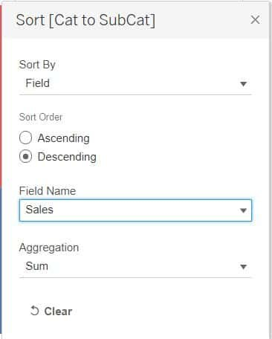

We need to have both the pie charts in the same order. So, lets change the first pie chart order to descending just like the second one.

step 16) Right click on "Product Category" color pill under second "AGG(avg(0))" Marks card and click on "Sort" option then change order to descending.

Lets setup action:

step 17) Click on the "Worksheet" and click on "Actions".

Click on "Add Action" then click on "Change Set Values".

Give the name as "Update Category Set".

Change Source Sheets to "Orders+(Store_Data)"

Select "Run Action On" type as Hover.

Change the Target set from "None" type to "Category Set".

Change radio button of "Clearing the selection will" to "Remove all values from set".

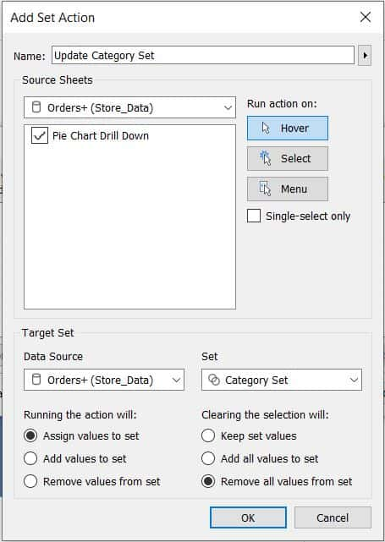

Click on OK.

Lets fix the colors in second filter according to the first filter.

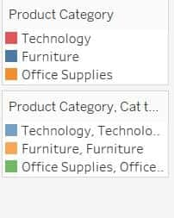

step 18) Click on the downward arrow of second filter and click on "Edit Colors".

Edit the colors as shown below:

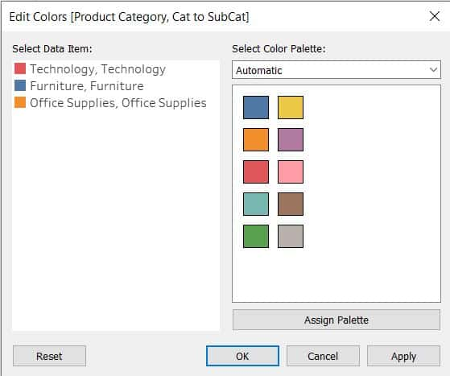

Now, we can see both the charts are in similar color as desired.

We can grade colors of sub categories within categories with respect to category colors.

For example, Red color of Technology shows graded colors of sub categories when we hover mouse on it.

To do color grading for sub categories with respect to categories:

step 19) Go to "Worksheet", click on "Actions".

In the "Actions" pop up window, click on "Edit".

Change "Run action on" type to "Select". Change radio button of "Clearing the selection will" to "Remove all values from set". Click on OK.

step 20) Now, select "Red" Segment i.e Technology on first pie chart and click on "Edit Colors" on the second filter as shown below:

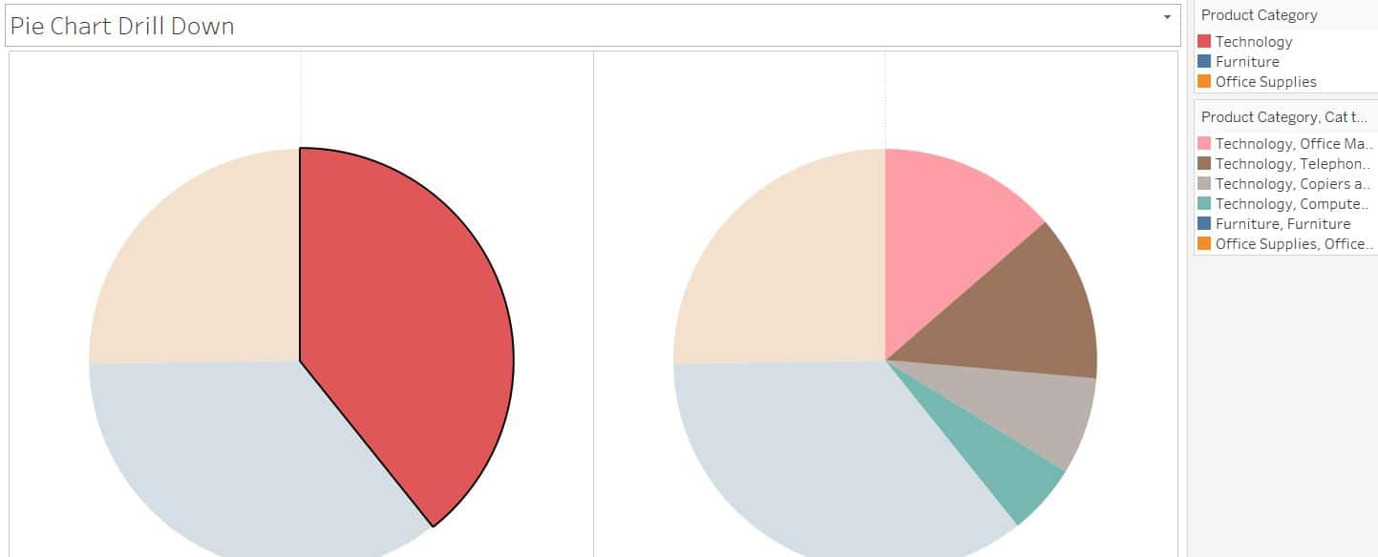

But, before assigning color palette to categories.

lets change the order of sub categories to ascending. so that sub category with high sale are in thick color which will be meaningful.

step 21) Right click on "Cat to SubCat" color pill under second "AGG(avg(0))" Marks card and click on "Sort" option to ascending order.

step 22) Click on the second filter and click on "Edit Colors" then assign palette type as Red for technology data items.

step 23) Similarly, follow step 20 and step 22 to do the same for other two categories. The only thing here is the color palette selection. select blue for furniture and orange for office supplies.

step 24) Right click on "Cat to SubCat" color pill under second "AGG(avg(0))" Marks card and click on "Sort" option to descending order.

step 25) Right click on second "AGG(avg(0))" pill in the Columns shelf and click on "Dual Axis".

step 26) Right click on avg(0) header which is displayed above pie chart and click on "Synchronize Axis". Again right click on avg(0) header and uncheck "Show Header".

step 27) Click on the first "AGG(avg(0))" Marks card and increase the Size of pie chart.

step 28) Now, Click on the second "AGG(avg(0))" Marks card.

Click on the Color and change opacity to 75% and select Border color as white.

step 29) Change the Border color as white for first "AGG(avg(0))" Marks card.

Now, we can see the visual as shown below:

